[YOUR EVENT NAME]
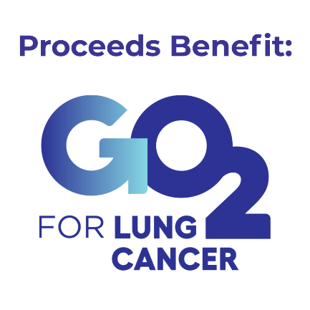
A portion of today’s sales will benefit GO2 for Lung Cancer and their programs dedicated to increasing lung cancer survival.

Your contribution will help provide one-on-one assistance, screening, and treatment navigation, as well as fund the latest research to accelerate cures, and change this disease from one of stigma to one of hope.
Join the community and learn more at go2.org.

DONATE TODAY!

(or replace QR code with one directing to your fundraising page)

